**Project Design Phase**

**Problem – Solution Fit Template**

|  |  |
| --- | --- |
| Date | 15 February 2025 |
| Team ID | Team -145206 |
| Project Name | Sociopedia |
| Maximum Marks | 2 Marks |

**Problem – Solution Fit Template:**

**1. Problem**

There is a growing demand for modern, customizable, and privacy-focused social networking platforms. Popular platforms often collect excessive data, lack personalization for smaller communities, or are too complex for niche use cases like college groups, startups, or local creators.

**2. Customer Behavior**

Users are seeking simpler, ad-free, community-focused alternatives to existing platforms. They prefer responsive design, media-sharing capabilities, and secure interactions. Many are moving toward smaller, interest-based platforms where they feel their data is respected.

**3. Solution**

We are building a **MERN stack-based social media platform** that is lightweight, secure, and feature-rich. It offers:

* User authentication and privacy controls (JWT-based)
* Post sharing with media
* Commenting and interaction
* Cloud-based file storage (e.g., Cloudinary)
* Clean, responsive user interface with scalable architecture

**4. Why This Solution Works**

* Built using modern tech (React, Node, MongoDB), allowing rapid development and iteration
* Custom features for community engagement and content control
* Modular architecture for easy expansion
* Deployable on cloud with horizontal scaling

**5. State of the Customer**

Current users are frustrated with data-heavy platforms and want simplified alternatives for community interaction. Early adopters, such as college students or creators, are ready to switch to platforms that are more engaging, lighter, and ad-free.

**6. Impact**

* Better control over content and interactions
* Increased privacy and trust
* Opportunity for niche groups to form communities
* 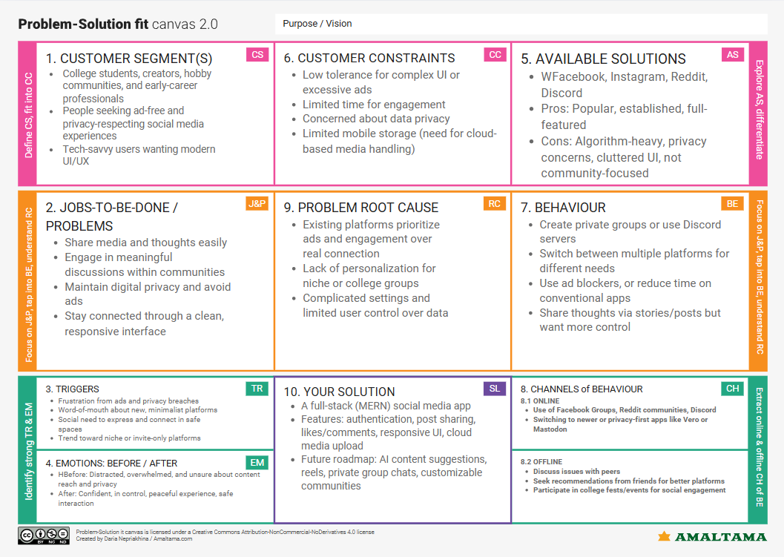Business model based on freemium features, promoted content, and analytics (with consent)

References:

1. <https://www.ideahackers.network/problem-solution-fit-canvas/>
2. <https://medium.com/@epicantus/problem-solution-fit-canvas-aa3dd59cb4fe>